Gold

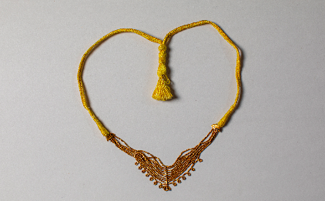
Microbeads; Gold; Findspot: Lothal, Gujarat, India; Archaeological Survey of India (2992)

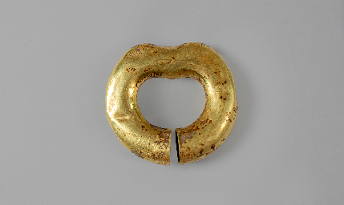
Wristlet; Gold; Late Harappan Period; Findspot: Mandi, Uttar Pradesh, India; Archaeological Survey of India (10/MDN/01)

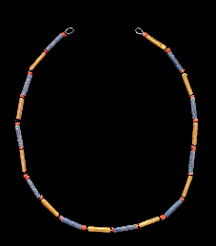
Necklace of Queen Puabi; Gold, carnelian and lapiz lazuli; Early Dynastic III, Findspot: Ur, Iraq; 3rd millenium BCE; The British Museum (1929,1017.237)

